|  |  |
| --- | --- |
| Exp. No.9  Date: | **Design of Lag, Lead Compensators and Evaluation of**  **Closed Loop Performance** |

# Aim

# The design lag lead compensator and evaluate the closed loop performance.

# Introduction

Lag and lead compensators play a crucial role in control systems, addressing challenges in system response, transient behavior, and steady-state performance. This topic explores the nuanced design and evaluation of these compensators, aiming to minimize system error and optimize functionality. Through parameter tuning and rigorous assessment of closed-loop performance, valuable insights into control system design principles are gained, applicable across various engineering contexts.

# Procedure

Step 1: Analyze the dynamic characteristics of the given system and derive its transfer function.

Step 2: Design the lag compensator by selecting appropriate parameters like time constant and gain.

Step 3: Design the lead compensator by choosing suitable parameters such as time constant and gain.

Step 4: Implement the designed lag and lead compensators in MATLAB using the Control System Toolbox.

Step 5: Analyze the closed-loop response, evaluating transient behavior, steady-state error, and overall stability.

**MATLAB Circuit**

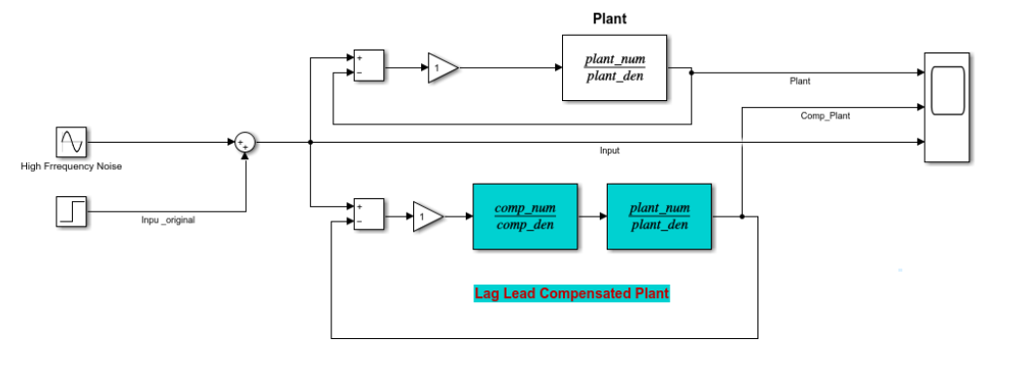

**MATLAB Code :** Lag Compensator

clc;

close all;

clearvars;

% Lag Compensator Design

plant_num = [5];

plant_den = [2 1 0];

plant_tf = tf(plant_num,plant_den);

comp_num = [20 1];

comp_den = [200 1];

comp_tf = tf(comp_num,comp_den);

% Plotting Gain and Phase margin for plant

figure;

margin(plant_tf);

grid on;

% Compensated System

lag_comp_sys = plant_tf*comp_tf;

disp(lag_comp_sys);

hold on;

margin(lag_comp_sys);

legend ('plant', 'comp_plant');

% Plotting Gain and Phase margin for compensator

figure;

margin(comp_tf);

grid on;

**Output Waveform**

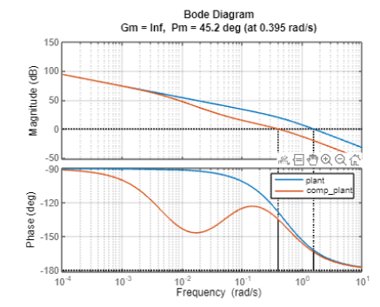

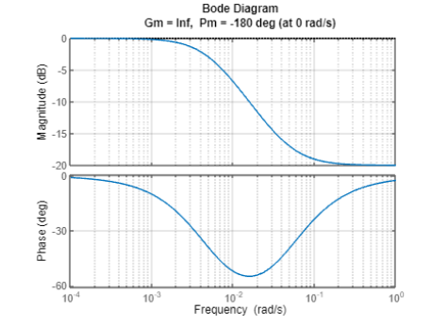

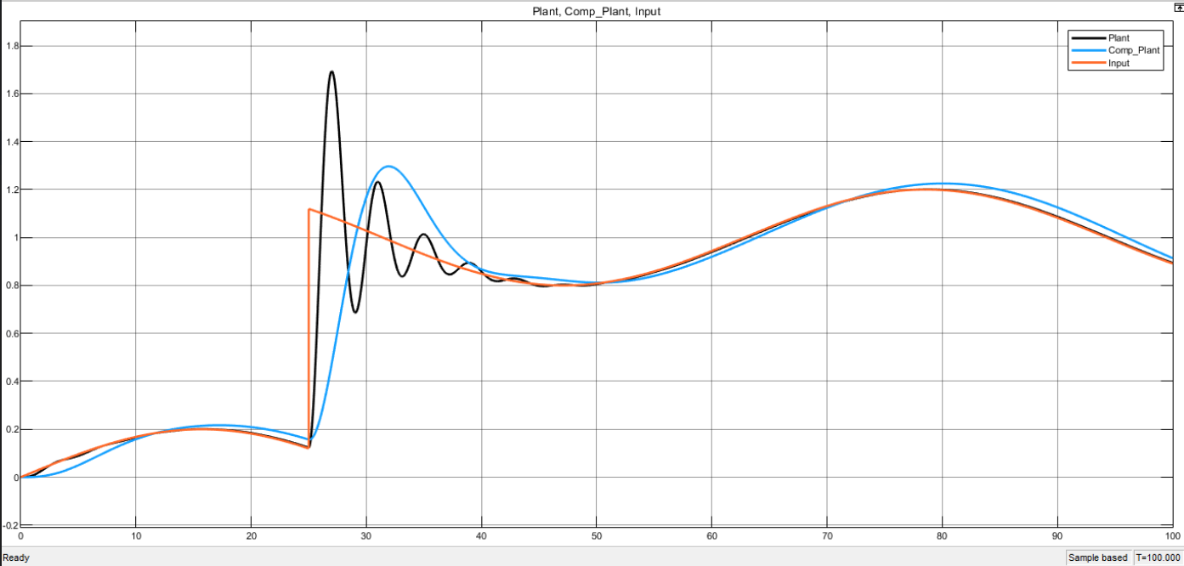

**MATLAB Code:** Lead Compensator

clc;

close all;

clearvars;

% Lead Compensator Design

plant_num = [15];

plant_den = [1 1 0];

plant_tf = tf(plant_num,plant_den);

comp_num = [0.36 1];

comp_den = [0.09 1];

comp_tf = tf(comp_num,comp_den);

% Plotting Gain and Phase margin for plant

figure;

margin(plant_tf);

grid on;

hold on;

% Compensated System

lead_comp_sys = plant_tf*comp_tf;

disp(lead_comp_sys);

margin(lead_comp_sys);

hold off;

legend ('plant', 'comp_plant');

% Plotting Gain and Phase margin for compensator

figure;

margin(comp_tf);

grid on;

**Output Waveform**

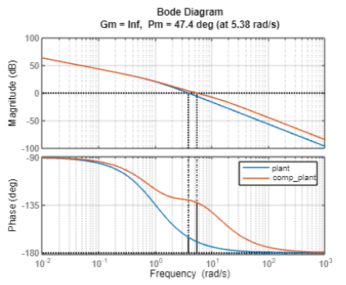

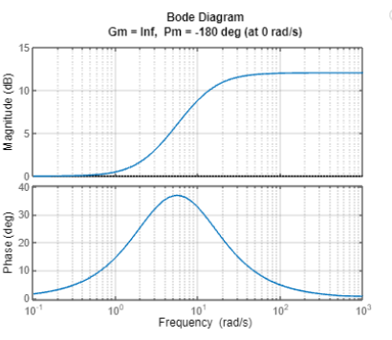

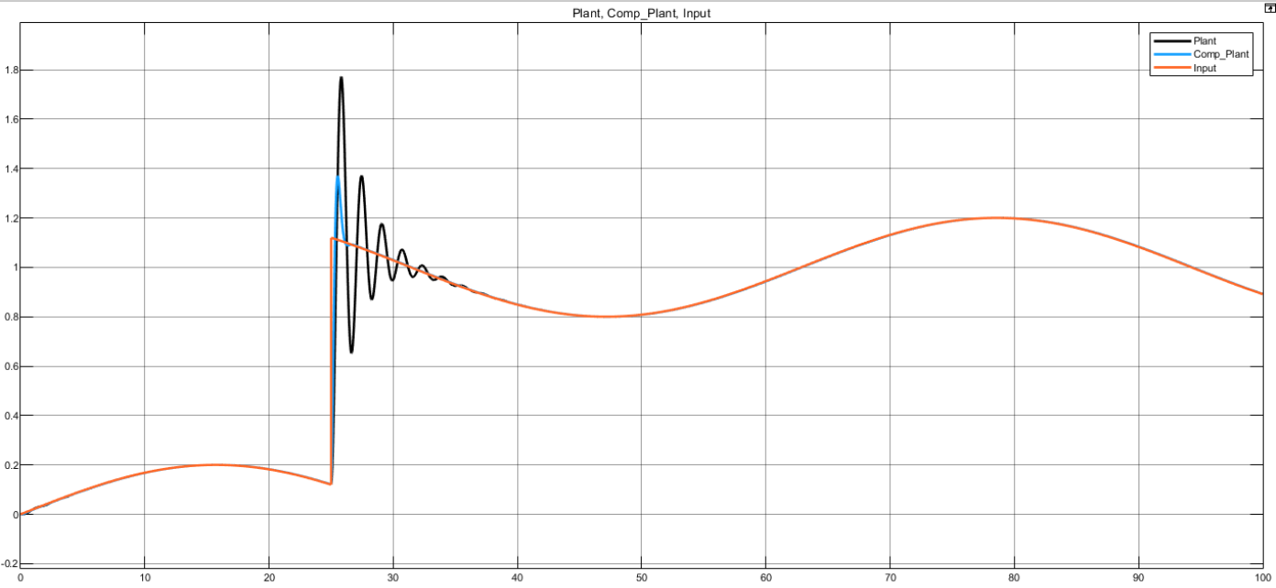

**Inference**

# Result

Thus, the lag, lead compensator has been simulated and the output waveform has been analyzed.